For Immediate Release: May 30, 2013
Contact: Ruth Wikler-Luker, Boom Arts / ruth@boomarts.org / 503-567-1644/ www.boomarts.org

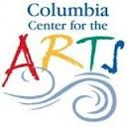 + 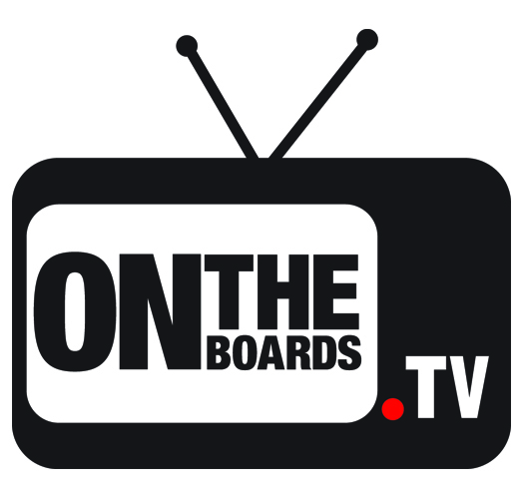 + 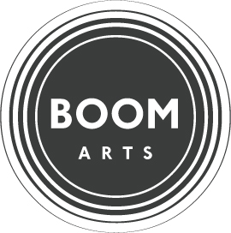

MULTI-CITY PARTNERSHIP BRINGS INNOVATIVE THEATRE-ON-FILM
AND DISCUSSION EVENT ON THE TOPIC OF IMMIGRATION
TO THE COLUMBIA CENTER FOR THE ARTS, HOOD RIVER
FEATURING TEATRO LÍNEA DE SOMBRA’S
AMARILLO
(Mexico)

Hood River, Oregon, June 5, 2013—Columbia Center for the Arts (Hood River), in partnership with OntheBoards.tv (Seattle) and Boom Arts (Portland), will screen Teatro Línea de Sombra’s beautiful, poignant, timely theatre work Amarillo, in a high-definition filmed version, on Wednesday, June 5 at 7:30pm, followed by a bilingual community conversation.

With a nuanced, rich language of contemporary visual and multimedia theatre, Teatro Línea de Sombra’s Amarillo evokes the hope and despair experienced by Mexican and Central American migrants attempting to cross the US/Mexico border. The piece expands our collective conversation about immigration and border issues with a poetic Mexican perspective.

Amarillo has toured throughout the US and around the world, resonating with audiences of all languages and backgrounds. On June 5, Hood River’s Columbia Center for the Arts, in collaboration with OntheBoards.tv and Boom Arts, will screen the HD film of the piece made for OntheBoards.tv, an online, on-demand site for the best of contemporary performance. The screening will be followed by a bilingual Spanish/English discussion with health promoter Gabriel Muro (Next Door Inc., Hood River) and Ruth Wikler-Luker, Curator and Producer of Boom Arts.

The screening and discussion will take place at the Columbia Center for the Arts, 215 Cascade Street, Hood River, OR 97031. A donation is suggested but no reservations are necessary. See www.columbiaarts.org for further details.

The Community Screenings Project is an extension of the live performance of Teatro Línea de Sombra’s Amarillo, and is made possible by the Doris Duke Charitable Foundation and Southern Exposure: Performing Arts of Latin America, a program of Mid Atlantic Arts Foundation in partnership with the National Endowment for the Arts and the Robert Sterling Clark Foundation.

Boom Arts presents, produces, and develops socially relevant theatre and performance in Portland and the Pacific Northwest. Please visit us at www.boomarts.org.

OntheBoards.tv is an on-demand website for HD-quality contemporary performance films available for stream, download or mobile viewing via individual or subscription purchase. Launched in January 2010, this first-of-its-kind site brings contemporary work to a wider public by filming top caliber performances with multiple high-definition cameras, editing the film collaboratively with the artists, and delivering them online as feature-length performance films. Filmed at On the Boards, as well as peer theaters across the country, the performances present a snapshot of the best new works by current leaders in dance, theater and music. Fans of contemporary performance have found better access to HD-quality videos of the artists they want to see regardless of where they live or their busy schedules at prices they can afford.

########

